IST769 Unit H - Key Value

## Agenda

1. Your Questions
2. Go over Problem Set
3. Unit Coursework Activities

## FRONT MATTER

Start your engines!

PS> **cd advanced-databases**

PS> **docker-compose up -d redis rediscommander retwis jupyter drill**

Redis-Commander: <http://localhost:8882>

Retwis Twitter Clone with Redis <http://localhost:5082>

Redis Client PS> **docker-compose exec redis redis-cli**

Redis Command List: <https://redis.io/commands/>

**Redis:**

* What is the storage model? (relational, document, etc…)  
  Key/Value Memcache Varnish

Redis supports data structures

* What are the logical model metaphors? (tables, keys constraints,notno etc…)
  + Key / Value
  + Type Structures Value, List (Stack, Queue, List), Hash (Tables)
* How does it scale horizontally? CAP? (after all - its a big data course!)
  + ??? Flexible runs in CP or AP
* Purpose of database? OLTP (CRUD) or OLAP/Analytics (CR)?
  + Storage, CRUD
* How do you design for it?
  + Weird
* How to connect to it from:
  + Client / Native Scripting Language
  + Drill / SQL
  + Spark / PySpark

## 1. Your Questions

Ask any questions you have here!

* For the following Command, HMSET a b c d e, (check all that apply) Which are the hash key(s)?
* 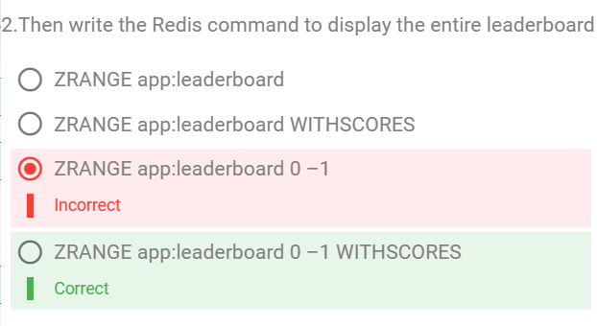

## 2. Coursework Activities

<http://openinsider.com/screener?s=MSFT>

<https://openinsider.com/screener?s=GOOG>

Web scrapers love to cache their webpages in redis!

* This way you can work on scraping the content without making too many requests to the page itself.
* Also you can scrape the same page historically (once per day or hour) and keep a history, of how the page “was”
* You can separate the code that transforms the page content from the code that requests the page itself

If we store the pages in Redis:

1. What data structure should be used?
2. What is a good namespace?
3. What is a good key name?
4. Perform some examples with redis commands

Many apps have an undo/redo buffer that tracks changes made in the application. Let’s Build a simple Undo / Redo buffer using a stack in Redis.

1. Which Data structure should be used?
2. What’s a good namespace?
3. What are we storing under the key?
4. Let’s do some examples in redis commands: